From: Ute Leipprand <ute.leipprand@t-online.de>  
Date: Fri, 4 Oct 2024 13:37:05 +0200  
Subject: Genealogy Leipprand:  
To: hans@leibbrandt.com

Lieber Hans,

Hier noch ein Foto des Wappens, das ich von den Leipprands habe. Mein Vater war Richard Leipprand, geb. 18.08.1926. Er starb bereits 2001.

Das Wappen sieht schon den auf der Website abgebildeten Wappen ähnlich.

Herzliche Grüße

Ute

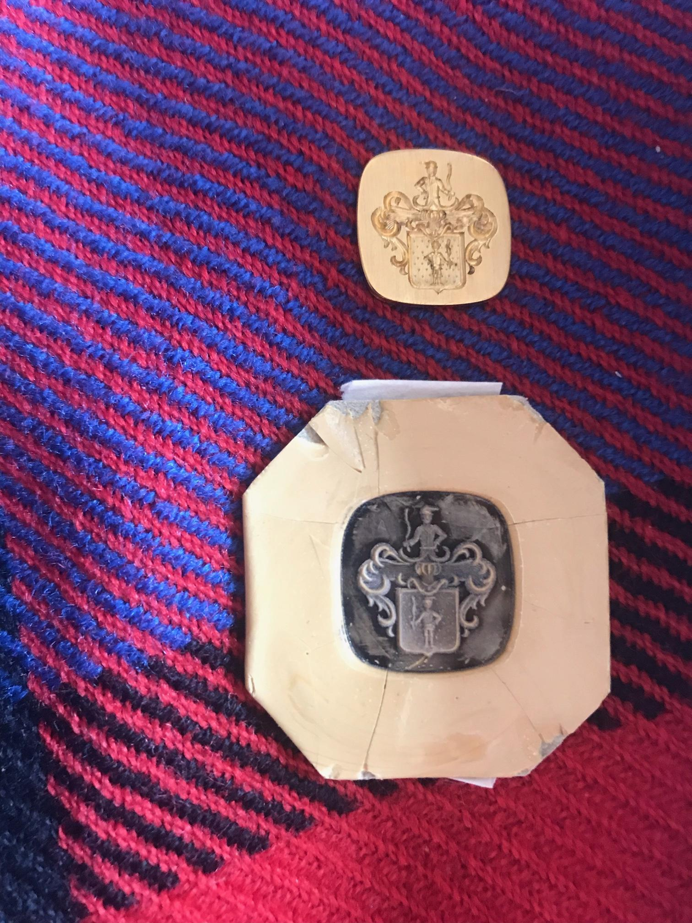

======================================================  
At 22:37 2024-09-30, Ute Leipprand wrote:

Dear Hans,   
I hope that you are fine. I found your contact when searching for ancestors of our family.   
Are you still working on this family tree?  
  
I am from leipprand family, partly wirh ancestors in Frankfurt, Stuttgart and Heilbronn.  
  
I would be interested in any exchange concerning ancestry.   
  
Looking forward to your answer  
  
Best regards  
UteLeipprand